AI TRAINING – DAY 3 ASSIGNMENT
Python Operators & Strings: Manipulate → Extract → Clean → Format
Practical + MCQ + Debugging + String Utility Project

1. Learning Goals
- Understand arithmetic, comparison, logical, assignment and membership operators.
- Understand strings, indexing, slicing and common string methods.
- Use f-strings to create readable dynamic output.
- Identify common operator and string errors.
- Combine all topics to build a practical text utility.
- Explain your solution in your own words.

2. Assignment Rules
- Type the programs yourself. Do not copy complete solutions.
- Before running code, predict the output.
- Test strings with spaces, uppercase/lowercase, empty input and unexpected input.
- You may use AI to explain a concept or error after attempting it yourself.
- For every practical problem write Input → Processing → Output.
- Keep at least one error you faced and explain how you fixed it.

3. Part A – Operators Exploration
Create operators.py and experiment with each group. Write at least 2 examples for every group.
Operator group | Operators / your observation
Arithmetic | + - * / // % **  Observation: this operator is used for addition, subtraction, multiplication, division, finding quotient, finding remainder and calculating power.
Comparison | == != > < >= <=  Observation: this operator will produce True or False
Logical | and or not  Observation: and needs the both conditions to be true.  Or needs at least one condition want to be True.  Not changes the conditions to True to False and False to True.
Assignment | = += -= *= /=  Observation: this operator is used to update the variable values easily.
Membership | in / not in  Observation: in checks whether something is present.  not in checks whether something is absent.
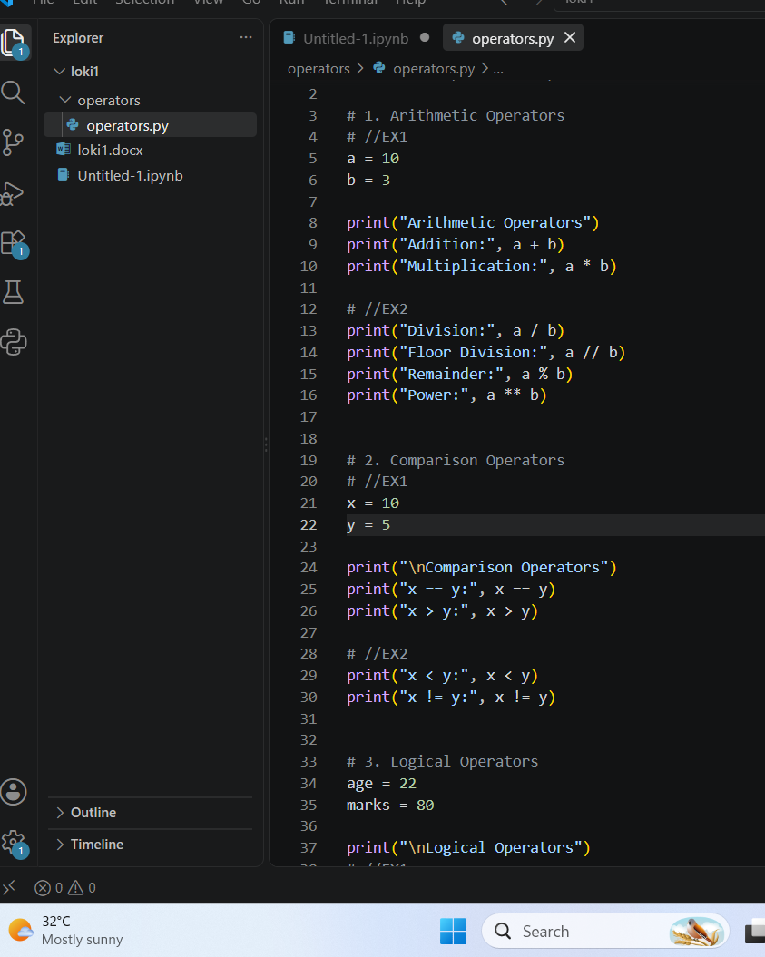

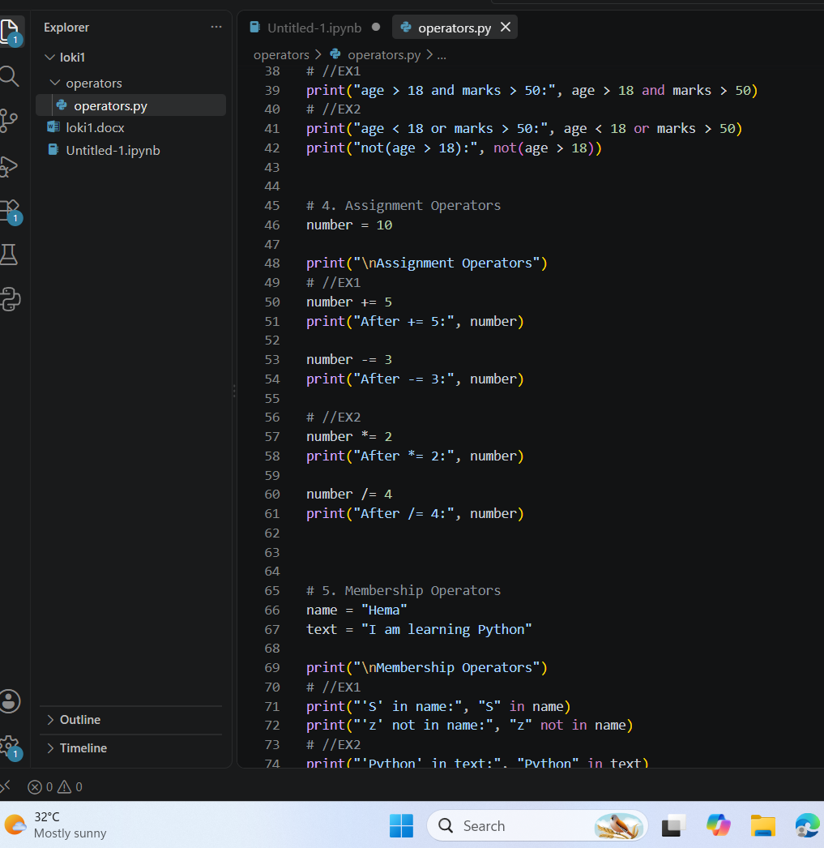
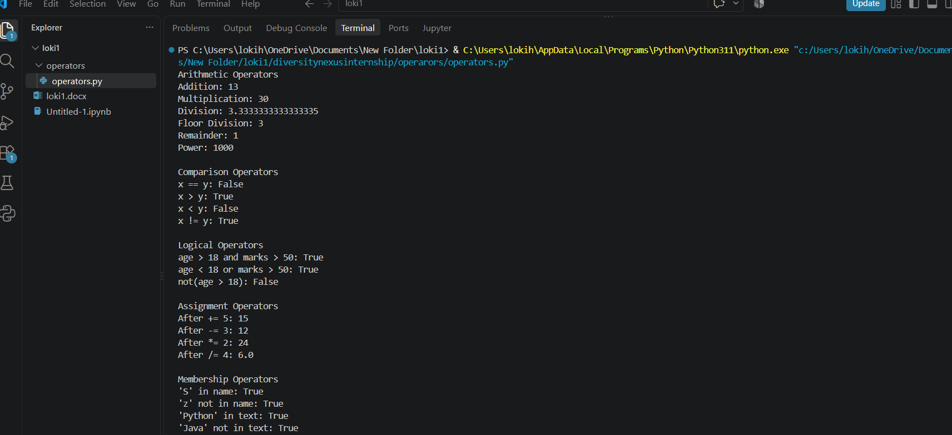

4. Part B – Operator Thinking
- What is the difference between / and //?
Ans: / gives the normal division result, usually including decimals.// gives the floor division result.
- When would % be useful in a real application?
Ans: % gives the remainder after division. It is useful for checking whether a number is even or odd.
- What does ** do?
Ans: it is the power operator. it raises one number to the power of another.
- What is the difference between = and ==?
Ans: = is used for assign the values.== is used for compare the two values are equal.
- What is the difference between != and not?
Ans: != is used to check whether two values are different. not changes True to False and False toTrue.
- What is the result of 10 > 5 and 3 < 2? Explain.
Ans: The first condition is True, but the second condition is False. with and, both conditions must be True.
- What is the result of 10 > 5 or 3 < 2? Explain.
Ans: The first condition is True, so or gives the True.
- What does not True produce?
Ans: False.
- What does 'Python' in 'I am learning Python' return?
Ans: True, Because the word “Python” exists inside the sentence.
- When would not in be useful?
Ans: it is useful when we want to check that something is not present in a string.

5. Part C – String Basics Lab
Use your own name or another sentence and run these experiments.
- Create a string and print it.
Ans: name= “Loki”
print(name)
output: Loki
- Print its length using len().
Ans: name=”Loki”
print(len(name))
output: 4
- Print the first character using [0].
Ans: name=”Loki”
print(name[0])
output: L
14. Print the last character using [-1].
Ans: name=”Loki”
print(name[-1])
output: I
15. print the first 3 characters using slicing.
Ans: name=”Loki”
print(name[:3])
output: Lok
16. print the last 3 characters using slicing.
Ans: name=”Loki”
print(name[-3])
output: oki
17. print every second character.
Ans: text= “Hemalatha”
print(text[::2])
output: Hmlta
18. Reverse the string using slicing.
Ans: text=”math”
print(text[::-1])
output: htam
19. Try an invalid index. What error occurs.
Ans: text=”math”
print(text[10])
output: IndexError
20. Try changing one character directly. What happens and Why.
Ans: name=”Loki”
name[0]=”]”
output: TypeError

6. Part D – String Methods Lab
Experiment with these methods and explain what each one does.
Method | Your example | What does it do?
lower() | name=”Loki”  Text=name.lower()  print(Text) | Converts all letters to lowercase like, Loki.
upper() | name=”Loki”  Text=name.upper()  print(Text) | Converts all letters to uppercase like, Loki.
title() | name=”mamatha bathula”  Text=name.tittle()  print(Text) | Makes each word start with uppercase.
strip() | name=” Mamatha “  Text=name.strip()  print(Text) | Removes spaces from the beginning and end of a string.
replace() | name=”i love brother”  Result=Text.replace(“brother”,”mom”)  print(Result) | Replaces text.
split() | Text=”kanna is so beautiful”  Result=Text.split()  print(Result) | Splits text into a list.
join() | Words=[“loki”,”is”, “best”]  Result=”,”.join(Words)  print(Result) | Joins items together.
startswith() | print(“Python. starts with(“Py”)) | Checks starting text.
endswith() | print(“Python. ends with(“on)) | Checks ending text.
find() | print(“python”.find(“t”)) | Finds the position of text.
count() | print(“apple”.count(“p”)) | Counts occurrences.

7. Part E – Indexing & Slicing Challenge
Use: text = "Artificial Intelligence"
21. Print the first character.
Ans: print(text[0])
output: A
22. print the last character.
Ans: print(text[-1])
output: e
23. Print the first 10 characters.
Ans: print(text[10])
output: Artificial
24. Extract the word Intelligence.
Ans: print(text[11])
output: intelligence
25. Reverse the complete string.
Ans: print(text[::-1])
output: ecnegilletni laicifitrA
26. Print every second character.
Ans: print(text[::2])
output: Atialtlgne
27. Print characters from index 3 to 12.
Ans: print(text[3:13])
output: ificial In
28. Find the index of the first 'i'.
Ans: print(text. find(“i”))
output: 2
29. Count the number of 'i' characters.
Ans: print(text. count(“i”))
output: 3
30. Predict what text[100] will do, then run it.
Ans: it produces index error.

8. Part F – f-Strings
31. Create name, age and city variables and display them in one sentence using an f-string.
name=”hema”
age+20
city=”kanigiri”
print(f” My name is {name}, I am {age} years old, and live in {city}.”)
32. Create a product, price and quantity and display a formatted bill.
product=”mobile”
price=22000
quantity=2
total=price*quantity
print(f” product: {product}”)
print(f” price: {price}”)
print(f” quantity: {quantity}”)
print(f” total: {total}”)
33. Display student name, total marks and average.
name=”Loki”
total=989
average=90
print(f” Student: {name}”)
print(f” Total Marks: {total}”)
print(f” Average: {average}”)
34. Use an f-string to display a calculation result.
a=23
b=43
print(f” {a}+{b} ={a+b}”)
35. Research decimal formatting and display a price with exactly 2 decimal places.
Price = 125.5
print(f"Price: ₹{price:.2f}")

9. Part G – MCQs: Basic
1. Which operator means multiplication?
- A. x
- B. *
- C. %
- D. //
2. What does % return?
- A. Division
- B. Quotient
- C. Remainder
- D. Power
3. What is the first string index?
- A. 0
- B. 1
- C. -1
- D. first
4. What is len('Python')?
- A. 5
- B. 6
- C. 7
- D. Error
5. Which gets the last character?
- A. text[0]
- B. text[-1]
- C. text[last]
- D. text[1]
6. Which converts text to lowercase?
- A. lower()
- B. small()
- C. down()
- D. lowercase
7. Which removes leading/trailing spaces?
- A. trim()
- B. clean()
- C. strip()
- D. remove()
8. Which checks membership?
- A. inside
- B. in
- C. has
- D. contains
9. Which is an f-string?
- A. f"Hello {name}"
- B. "f Hello"
- C. format f(name)
- D. string(name)
10. Which compares equality?
- A. =
- b. ==
- C. ===
- D. equals

10. Part H – MCQs: Medium
1. What is 17 // 5?
- A. 3
- B. 3.4
- C. 2
- D. 4
2. What is 17 % 5?
- A. 3
- B. 2
- C. 3.4
- D. 0
3. What does 'Python'[1:4] return?
- A. Pyt
- B. yth
- C. ytho
- D. tho
4. What does 'Python'[-3:] return?
- A. tho
- B. hon
- C. yth
- D. Python
5. What does ' hello '.strip() return?
- A. ' hello'
- B. 'hello '
- C. 'hello'
- D. Error
6. What does 'hello'.upper() return?
- A. hello
- B. HELLO
- C. Hello
- D. Error
7. What does 'a,b,c'.split(',') return?
- A. inside
- B. ['a','b','c']
- C. ('a','b','c')
- D. Error
8. Which checks if AI occurs in text?
- A. text.contains('AI')
- B. 'AI' in text
- C. text.has('AI')
- D. contains(text,'AI')
9. What happens with text[50] when text has 10 characters?
- A. None
- B. ''
- C. IndexError
- D. False
10. Why use f-strings?
- A. Insert values/expressions into strings cleanly
- B. Make strings immutable
- C. Convert values to int
- D. Remove spaces

11. Part I – MCQs: Thinking
1. Which is true about strings?
- A. They can always be changed character-by-character
- B. They are immutable
- C. They only contain letters
- D. They cannot be sliced
2. Best way to clean ' PHANI gorantla ' for display?
- A. strip().title()
- B. title().strip()
- C. Both A and B
- D. clean()
3. What does text[::-1] do?
- A. Deletes text
- B. Reverses text
- C. Sorts text
- D. Gets first character
4. Best simple test for '@' in an email?
- A. '@' in email
- B. email == '@'
- C. email.contains('@')
- D. email.has('@')
5. replace() generally:
- A. Returns a transformed string
- B. Always changes the original string in place
- C. Converts to list
- D. Deletes the variable
6. x='5', y=2. Which gives numeric 10?
- A. x*2
- B. int(x)*2
- C. str(x)*2
- D. x+2
7. Which formats 12.5 as 12.50?
- A. f'{price:.2f}'
- B. f'{price:2}'
- C. f'{price.float}'
- D. f'{price.decimal(2)}'
8. What should usually happen before validating text entered with spaces?
- A. strip()
- B. reverse()
- C. split() always
- D. replace with None
9. A common cause of IndexError is:
- A. Invalid index
- B. Using an f-string
- C. lower()
- D. +
10. Why keep raw input and cleaned input conceptually separate?
- A. It makes transformations easier to test
- B. Python requires it
- C. Strings cannot be stored
- D. It prevents every error

12. Part J – 5 Practice Problems
Problem | Task | Topics
Practice 1 – Username Cleaner | Ask for a username, remove surrounding spaces, convert to lowercase and display the cleaned value. | strip + lower + f-string
Practice 2 – Name Formatter | Ask first and last names in random case and display a properly formatted full name. | strip + title + f-string
Practice 3 – Word Analyzer | Ask for a sentence. Display length, first character, last character, spaces count and vowel count. Do not use loops. | len + indexing + count
Practice 4 – Email Inspector | Ask for an email. Check '@', check whether it ends with '.com' or '.in', and show the position of '@'. | in + endswith + find
Practice 5 – Product Code Extractor | For code IND-MOB-2026-001, extract country, category, year and serial using slicing. | indexing + slicing + f-string
For each: Input → Expected Output → Code → 2 test cases → 1 edge case → explanation.

Practice 1 – Username Cleaner
Task: Ask for a user name, remove surrounding spaces, convert to lowercase and display the cleaned value.
Topics: strip() + lower() + f-string
Input:
A username with some spaces and capital letters.
Expected Output:
The username should have no extra spaces and should be in lowercase.
Code:
username = input("Enter username: ")
cleaned = username.strip().lower()
print(f"Cleaned username: {cleaned}")
Test Case 1:
Input: Hemalatha
Output: Cleaned username: Hemalatha
Test Case 2:
Input: Lokesh
Output: Cleaned username: Lokesh
Edge Case:
Input: Hema
Output: Cleaned username: Hema
Explanation:
strip() removes spaces from the beginning and end. lower() converts capital letters to small letters.

Practice 2 – Name Formatter
Task: Ask first and last names in random case and display a properly formatted full name.
Topics: strip() + title() + f-string
Input:
First name and last name in any case.
Expected Output:
Both names should start with a capital letter.
Code:
first_name = input(“Enter first name : ”)
last_name = input(“Enter last name : ”)
print(f” You full name : {first_name.strip().title()} {last_name.strip().title()}”)
Test Case 1:
Input: Hemalatha, Bathula
Output: Full name: Hemalatha Bathula
Test Case 2:
Input: RAHUL, KUMAR
Output: Full name: Rahul Kumar
Edge Case:
Input: loki, yadav
Output: Full name: loki yadav
Explanation:
strip() removes extra spaces and title() makes the first letter of each word capital.

Practice 3 – Word Analyzer
Task: Ask for a sentence. Display length, first character, last character, spaces count and vowel count. Do not use loops.
Topics: len() + indexing + count()
Input:
A sentence.
Expected Output:
Length, first character, last character, number of spaces and number of vowels.
Code:
text = input("Enter a sentence: ")
vowel_count = ( text.count("a") + text.count("e") +
text.count("i") + text.count("o") +
text.count("u") +
text.count("A") + text.count("E") +
text.count("I") + text.count("O") +
text.count("U")
)
print(f"Length: {len(text)}")
print(f"First character: {text[0]}")
print(f"Last character: {text[-1]}")
print(f"Spaces: {text.count(' ')}")
print(f"Vowels: {vowel_count}")
Test Case 1:
Input: Hemalatha
Output:
- Length: 9
- First character: H
- Last character: a
- Spaces: 0
- Vowels: 4
Test Case 2:
Input: I love Python
Output:
- Length: 13
- First character: I
- Last character: n
- Spaces: 2
- Vowels: 4
Explanation:
len() finds the total number of characters. [0] gives the first character and [-1] gives the last character. count() is used to count spaces and vowels.

Practice 4 – Email Inspector
Task: Ask for an email. Check @, check whether it ends with .com or .in, and show the position of @.
Topics: in + endswith() + find()
Input:
An email address.
Expected Output:
Whether @ is present, whether it ends with .com or .in, and the position of @.
Code:
email = input("Enter email: ")
contains = "@" in email
valid_end = email.endswith(".com") or email.endswith(".in")
at_position = email.find("@")
print(f"Contains @: {contains}")
print(f"Ends with. com or. in: {valid_end}")
print(f"Position of @: {at_position}")
Test Case 1:
Input: hema@gmail.com
Output:
- Contains @: True
- Ends with .com or .in: True
- Position of @: 5
Test Case 2:
Input: githa@yahoo.in
Output:
- Contains @: True
- Ends with. com or. in: True
- Position of @: 5
Edge Case:
Input: hemagamil.com
Output:
- Contains @: False
- Ends with .com or .in: True
- Position of @: -1
Explanation:
in checks whether @ is present. endswith() checks how the email ends. find() gives the position of @. If it is not found, find() gives -1.

Practice 5 – Product Code Extractor
Task: For code IND-MOB-2026-001, extract country, category, year and serial using slicing.
Topics: Indexing + slicing + f-string
Input:
A product code like IND-MOB-2026-001.
Expected Output:
Country: IND
Category: MOB
Year: 2026
Serial: 001
Code:
code = input("Enter product code: ")
country = code[0:3]
category = code[4:7]
year = code[8:12]
serial = code[13:16]
print(f"Country: {country}")
print(f"Category: {category}")
print(f"Year: {year}")
print(f"Serial: {serial}")
Test Case 1:
Input: IND-MOB-2026-001
Output:
- Country: IND
- Category: MOB
- Year: 2026
- Serial: 001
Test Case 2:
Input: CAN-CAP-2025-025
Output:
- Country: USA
- Category: LAP
- Year: 2025
- Serial: 025
Edge Case:
Input: IND-TAA-2026-999
Output:
- Country: IND
- Category: TVX
- Year: 2026
- Serial: 999
Explanation:
Slicing is used to take specific parts from the product code. For example, code[0:3] takes the first 3 characters.

13. Part K – Debugging Lab

Bug 1
name = input('Name: ')
print(name[20])
Why can this fail? Fix it.
Corrected code / explanation:
name = input("Name: ")
if len(name) > 20:
print(name[20])
else:
print("The name is too short.")
explanation: Before using an index, we should check whether that index actually exists.

Bug 2
age = '20'
print(f'Age: {age + 1}')
Fix it.
Corrected code / explanation:
age = '20'
print(f' Age: {int(age) + 1}')
explanation: int(age) converts the string ‘20’ into the integer 20.then 1 can be added to it.

Bug 3
name = 'phani'
age = 30
print('Hello ' + name + age)
Identify the type problem and fix it.
Corrected code / explanation:
name = 'phani'
age = 30
print(f"Hello {name}, your age is {age}")
explanation: The f-string allows us to easily combine text and numbers in one sentence.(name) and (age) insert their values into the string.

Bug 4
email = input('Email: ')
print(email.endswith('.com'))
Test with 3 inputs and explain.
Corrected code / explanation:
email = input("Email: ")
email = email.strip().lower()
print(email.endswith(".com") or email.endswith(".in"))
explanation: The bug is related to string validation. The corrected code checks the email after removing and converting it to lowercase.

Bug 5
code = 'IND-MOB-2026-001'
print(code[20])
Find the valid index range and fix the requirement.
Corrected code / explanation:
code=’IND-MOB-2026-001’
print(code[0])
explanation: Python starts counting string positions from 0 to 16 so code[20] causes IndexError

Bug 6
text = ' hello world '
print(text.upper().strip())
Does it work? Explain the order of operations.
Corrected code / explanation: text = ' hello world '
cleaned = text.upper().strip()
print(cleaned)
explanation: First, upper() changes the letters to uppercase. Then, strip() removes the extra spaces from both ends.

14. Part L – Main Project: Text-Cleaning & Profile Formatter
Build a practical Python program that accepts messy profile information and converts it into a clean, readable profile.

Scenario
A company receives profile data in inconsistent formats. Names may contain extra spaces, emails may use mixed cases, and cities may be entered randomly. Your program should clean the data and generate a professional profile summary.

Required Inputs
- Full name
- Email address
- Phone number
- City
- Job role
- Short bio

Must-Have Requirements
- Remove leading/trailing spaces.
- Format the full name using title().
- Convert email to lowercase.
- Format city and job role neatly.
- Calculate bio character count.
- Check whether the email contains '@'.
- Check whether the email ends with a supported domain such as .com or .in.
- Extract first name from the full name.
- Extract last name using string logic.
- Display the profile using f-strings.
- Show a small data-quality section.
- Test with messy uppercase/lowercase and extra spaces.

Expected Output Example
================ PROFILE ================
Name : Phani Gorantla
First Name : Phani
Email : phani@example.com
Phone : 9876543210
City : Hyderabad
Role : Software Developer
Bio Length : 42 characters
------------- DATA QUALITY -------------
Email Valid : Yes
=========================================
Do not hard-code the example. The program must work with any user's input.

15. Project Bonus Challenges
- Clean repeated spaces inside a name.
- Validate phone number length.
- Check that the full name contains at least two words.
- Generate initials from the name.
- Generate a username from the person's name.
- Create a one-line professional bio using an f-string.
- Display a simple data-quality percentage.
Code :
full_name = input("Enter full name: ").strip().title()
email = input("Enter email: ").strip().lower()
phone = input("Enter phone number: ").strip()
city = input("Enter city: ").strip().title()
job_role = input("Enter job role: ").strip().title()
bio = input("Enter short bio: ").strip()
name_parts = full_name.split()
if (len(phone) > 10):
print("Invalid phone number")
else:
print("Phone number is valid")
if (len(name_parts) >= 2):
print("Full name is valid")
else:
print("Please enter first and last name")
username = full_name.lower().replace(" ", "")
print(f"Username: {username}")
professionalBio = (f"{full_name} is a {job_role} from {city}." )
print(professionalBio)
first_name = name_parts[0]
bio_length = len(bio)
has_at = "@" in email
supported_domain = email.endswith(".com") or email.endswith(".in")
if has_at and supported_domain:
email_valid = "Yes"
else:
email_valid = "No"
print("\n============ PROFILE =============")
print(f"Name : {full_name}")
print(f"First Name : {first_name}")
print(f"Last Name : {last_name}")
print(f"Email : {email}")
print(f"Phone : {phone}")
print(f"City : {city}")
print(f"Role : {job_role}")
print(f"Bio Length : {bio_length} characters")
print("\n------------- DATA QUALITY -------------")
print(f"Email Valid : {email_valid}")
print("=======================")

16. Project Test Cases
Test | Input condition | Expected behaviour | Actual result
1 | Normal clean input | Clean profile | Profile is displayed correctly.
2 | Extra spaces around fields | Spaces removed | Extra spaces are removed.
3 | Random uppercase/lowercase | Proper formatting | Text is converted into a consistent format.
4 | Invalid-looking email | Flag data quality | Program identifies the email as invalid.
5 | Short/missing optional data | Program should handle it sensibly | Program continues without crashing.

17. Explain Your Project
- What is the difference between cleaning data and formatting data?
Ans: Cleaning data means removing unwanted or incorrect things from the input.
Formatting means making the cleaned data look neat.
- Which string methods did you use and why?
Ans: strip()-to remove extra spaces at the beginning and end.
lower()-to convert email into lowercase.
upper()-to convert e mail into uppercase.
join()-to remove repeated spaces.
split()-to separate words.
count()-to count characters.
replace()-to replace unwanted text when required.
- Where did you use indexing?
Ans: I used indexing to access individual characters.
- Where did you use slicing?
Ans: Slicing is used when we want a part of a string.
- Why are f-strings useful here?
Ans: f-strings are useful because they allow us to easily put variables inside text.
- What error did you face?
Ans: One common error I faced was:
IndexError
It happened when I tried to access an index that did not exist.
- How did you test edge cases?
Ans: I tested the program with:
- Empty input
- Extra spaces
- Uppercase text
- Lowercase text
- Mixed-case text
- Short names
- Invalid-looking emails
- Different email domains
- Long sentences
This helps make sure the program does not fail for unusual input.

- If this processed 1 lakh profiles, what would you improve first?
Ans: I would first improve data validation and performance.

18. Final Self-Check
Skill | Yes | Need Practice | Notes
Use arithmetic/comparison/logical operators | Yes | ☐ | I can use operators like +,-,>,<,==, and, or.
Explain = vs == | Yes | ☐ | It is used to assign a value, while == is used to compare two values.
Manipulate strings | Yes | ☐ | I can join, change and work with text strings.
Use positive and negative indexing | Yes | ☐ | I can access characters from the beginning or from the end of a string.
Use slicing | Yes | ☐ | I can take a particular part of a string using slicing.
Use string methods | Yes | ☐ | I can use methods like upper(), lower(), replace(), strip() and replace().
Use in/not in | Yes | ☐ | I can check whether a character or word present in a string.
Use f-strings | Yes | ☐ | I can put variables values directly inside a string using f” ”.
Debug IndexError/type problems | Yes | ☐ | I can identify simple index and datatype errors and correct them.
Build the final text utility | Yes | ☐ | I can combine these concepts to create a simple text-processing program.

19. Submission Checklist
- Operator experiments
- Operator questions
- String exploration
- String-method table
- Indexing/slicing challenge
- f-string exercises
- 30 MCQ answers
- 5 practice programs
- Debugging Lab
- Text-Cleaning & Profile Formatter
- Project test cases
- Project explanation and self-check

